**Welcome to the REAL CRADLE OF HUMANKIND**

**Discover the ancient stone ruins and vanished civilisations of southern Africa**

The best kept secret on the way to the Kruger Park, is in the town of Waterval Boven, which lies in the heart of millions of ancient stone ruins that cover large parts of southern Africa, dating back over 200,000 years.

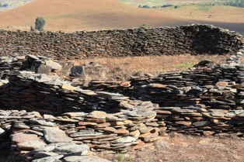 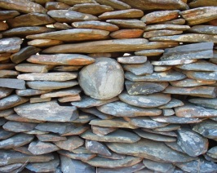 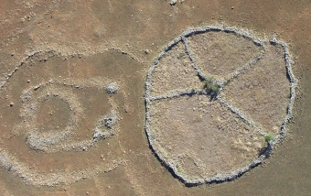 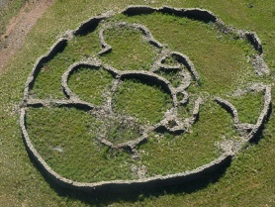 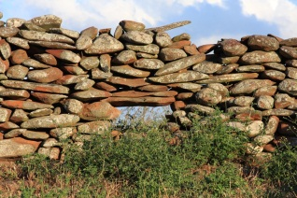

Long before the Egyptians saw the light of day, this vanished civilisation worshiped the Sun, they carved the first Sphinx and Horus Bird, built an ancient calendar aligned with Orion, (ADAM’S CALENDAR), and they were obsessed with gold. Their mysterious tools and artefacts indicate that they had an advanced knowledge of the laws of nature and they used SOUND & FREQUENCY as a tool – this is why we call this the first Silicone Valley. Archaeological finds connect these ruins to ancient civilisations like the Egyptians, Phoenicians, Dravidians, The Maya, Romans, Greeks and the Anunnaki gods of the Sumerians. This is an unforgettable treat for those who seek deeper knowledge and truth about our human origins. And for those who have seen sites like Stonehenge, The Giza Pyramids or Machu Pichu; the Stone Circles of South Africa will complete your journey.

**TOURS TO ANCIENT RUINS and ADAM’S CALENDAR**

Visit the **Stone Circles Museum** with a large display of mysterious tool and artefacts dating back over 200,000 years – Take a walk among the largest cluster of ancient stone ruins anywhere in the world – And visit **Adam’s Calendar**, which is known by African Shamans as ***Inzalo Y’langa*** or ***“Birthplace of the Sun***”, where humanity was created by the gods. Sacred ceremonies were held at this site until the 1950s.

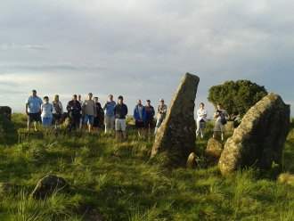 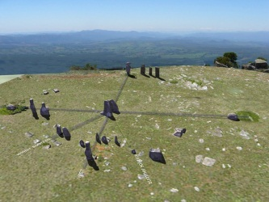 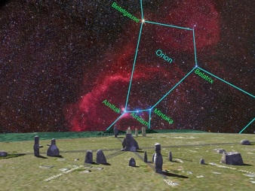 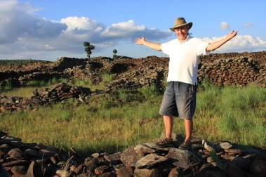

**STONE CIRCLE COUNTRY KITCHEN, CHALETS & BACKPACKERS ACCOMMODATION**

Enjoy our fabulous country cooking made with love & veggies from our very own garden – Stylish accommodation in the company of conscious owners AND sundowners on the river deck.

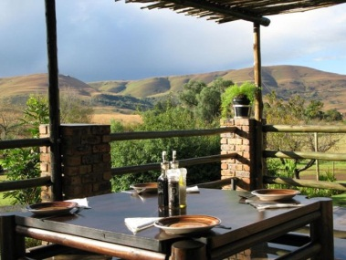 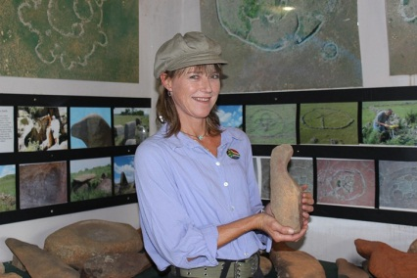 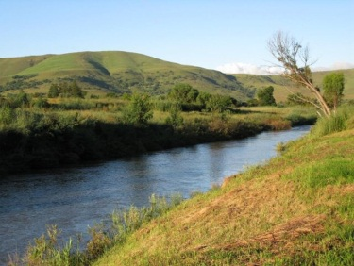

Contact: **Andrea** - your tour guide and host

Tel: 013 257 0479 Cell: 084 674 2525 Email: <michaeltellingertours@gmail.com>

STONE CIRCLE MUSEUM AND COUNTRY KITCHEN 17 ZASM Road, Waterval Boven, 1195

By the Elands River